35.60: The passage of fringes indicates an effective change in path length, since the wavelength of the light is getting shorter as more gas enters the tube.
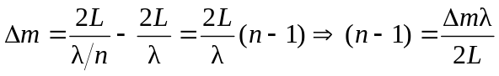.
So here:
